Bradley Davis

This document explains the components of CougSat-1 from a high level, and their integration.

CougSat-1

Cougs in Space’s First Satellite

Revision: 1.0.1



Table of Contents

1 Introduction 2

1.1 Background 2

1.2 Environmental Conditions 3

2 Mission Objective 4

3 Design Criteria 5

4 Design Considerations 6

5 Spacecraft Design 7

5.1 Mission Support System 8

5.1.1 IHU – Internal Housekeeping Unit 8

5.1.2 EPS – Electrical Power System 8

5.1.3 ADCS – Attitude Determination and Control System 8

5.1.4 RCS – Radio Communication System 8

5.1.5 IFJR – In-Flight JTAG Reprogrammer 9

5.1.6 Mechanical Structure 9

5.2 Payload 9

5.2.1 Validating the Mission Support System 9

5.2.2 Germination Experiment 9

5.2.3 Earth Imaging 9

6 Spacecraft Operation 10

6.1 Before Deployment 10

6.2 Immediately Following Deployment 10

6.3 Normal Operations 10

6.3.1 Beacon 10

6.3.2 Charging 10

6.3.3 Data Transmission 11

6.3.4 Science 11

6.3.5 Eclipsed 11

6.4 Safe Mode 11

# 1 Introduction

CougSat-1 is a 1U (single CubeSat unit) nanosatellite created by Washington State University’s (WSU) Cougs in Space club (CiS). The aim of this document is to describe CougSat-1 entirely from objective to top level design. Upon launch, CougSat-1 will become WSU’s first satellite and pave the way for many more to come.

## 1.1 Background

A CubeSat is a nanosatellite (wet mass: 1 to 10 kg) that is comprised of units, each a 100 mm cube, see figure 1. Cal Poly and Stanford developed the CubeSat specifications. In brief, a single unit is a 100 mm cube with a mass of up to 1.33 kg. A CubeSat can span multiple units: 1U, 2U, 3U, 6U, and 12U. Cal Poly also created the CubeSat deployment system, called the Poly Picosatellite Orbital Deployer (P-Pod). The P-Pod uses a spring mechanism to push the CubeSats out into orbit from the launch provider’s vehicle. Visit the CubeSat website at [cubesat.org](http://cubesat.org) for more information.

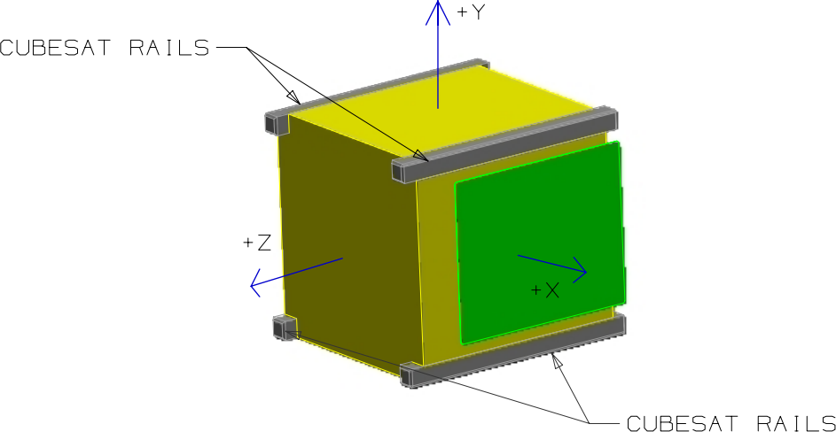

Figure 1: 1U CubeSat. Credit: Cal Poly CubeSat Program

## 1.2 Environmental Conditions

CubeSats reside in low earth orbit at an altitude between 200 and 900 km. Throughout designing, CougSat-1 assumes an orbital altitude of 600 km, unless otherwise specified. At this altitude, the orbital period is about 90 minutes and the mission lifespan is about a year. The mission lifespan depends on actual orbital properties and one year is a reasonable minimum for lifespan driven design choices. Not until ejection from the launch provider will CougSat-1’s orbit be known for certain.

At 600 km, CougSat-1 will be orbiting with a speed of 7.6 kms-1. Although atmospheric drag is the primary cause of orbital decay, it can usually be assumed to be negligible. Thus, CougSat-1 will be essential in free-space. During its orbit of about 90 minutes, roughly 30 minutes are spent eclipsed behind the earth. This duration varies on the beta angle of the orbit, worst case scenario yields a minimum solar duration of 59%[1]. The sun irradiates a substantial amount of energy which heats up CougSat-1. When eclipsed, this heat irradiates away, and the temperature begins to drop. The temperature can fluctuate between 120°C and -100°C every orbit[2]. The magnetic field strength is similar to that on Earth’s surface: 25nT to 60 nT[3].

# 2 Mission Objective

The mission objective of CougSat-1 is as follow:

1. Develop a reliable and robust mission support system for nanosatellites
2. Test an experiment apparatus studying plant germination in micro gravity
3. Put a cougar into orbit
4. Broadcast “Go Cougs!” around the world

As CougSat-1 is the first satellite created at WSU, the primary objective is to **develop a reliable and robust mission support system for nanosatellites**. The mission support system consists of all the subsystems on the satellite expect those relating to the payload. These include: ADCS, EPS, IHU, RCS, and the mechanical structure. A reliable and robust design of these components will improve the development of future CubeSats as only the payload specific subsystems will need to be designed and tested.

The secondary objective comes from the Astrobiology department at WSU. They requested CougSat-1 to **test an experimental apparatus** that will study plant germination in micro gravity. As humans are preparing for long distance space travel, sustainable food supplies need to be researched to ensure the travelers survive their trip. A future CougSat will have a full experiment researching agriculture in micro gravity.

The last two objectives are to share the WSU pride with as many people as possible. CougSat-1 will **put a cougar into orbit** and **broadcast “Go Cougs!”** around the world. Every photo CougSat-1 takes will have a cougar head in the corner. Every beacon transmission will end with an enthusiastic Go Cougs.

# 3 Design Criteria

CougSat-1 must possess the following features:

* Highly reliable primary communication system for commands and telemetry
* EPS capable of sustaining CougSat-1 during the entire orbit
* Mechanical structure to support and protect the components
* ADCS to orient CougSat-1 at points of interest or the sun for charging
* Plant germination experiment apparatus
* Radio beacon to identify and track CougSat-1 during communication passes, normally transmitting telemetry and “Go Cougs!”
* Visible camera to image Earth and CougSat-1’s cougar head

In addition, CougSat-1 should possess the following additional features:

* High speed secondary communication system for payload data transfer
* Deployable solar panels for less time charging and more time performing payload operations
* Visible light beacon for anyone to see CougSat-1 at night

# 4 Design Considerations

The primary design considerations for CougSat-1 come from the specifications created by [CubeSat](http://www.cubesat.org/resources/) and the environmental conditions experienced in low Earth orbit. These considerations ensure that CougSat-1 will successfully be placed in LEO and survive for at least one year, the mission lifespan.

The secondary design considerations come from the mission objective and design criteria. Every component on CougSat-1 should contribute towards achieving these goals. These considerations ensure that CougSat-1 will successfully complete its mission.

Any tertiary design considerations are unique to each subsystem and are explained in their documentation.

# 5 Spacecraft Design

This section describes CougSat-1 from a high-level perspective. The various subsystems all interact over the shared backplane. A functional block diagram of CougSat-1 is presented in figure 2 and a preliminary 3D rendering is shown in figure 3.

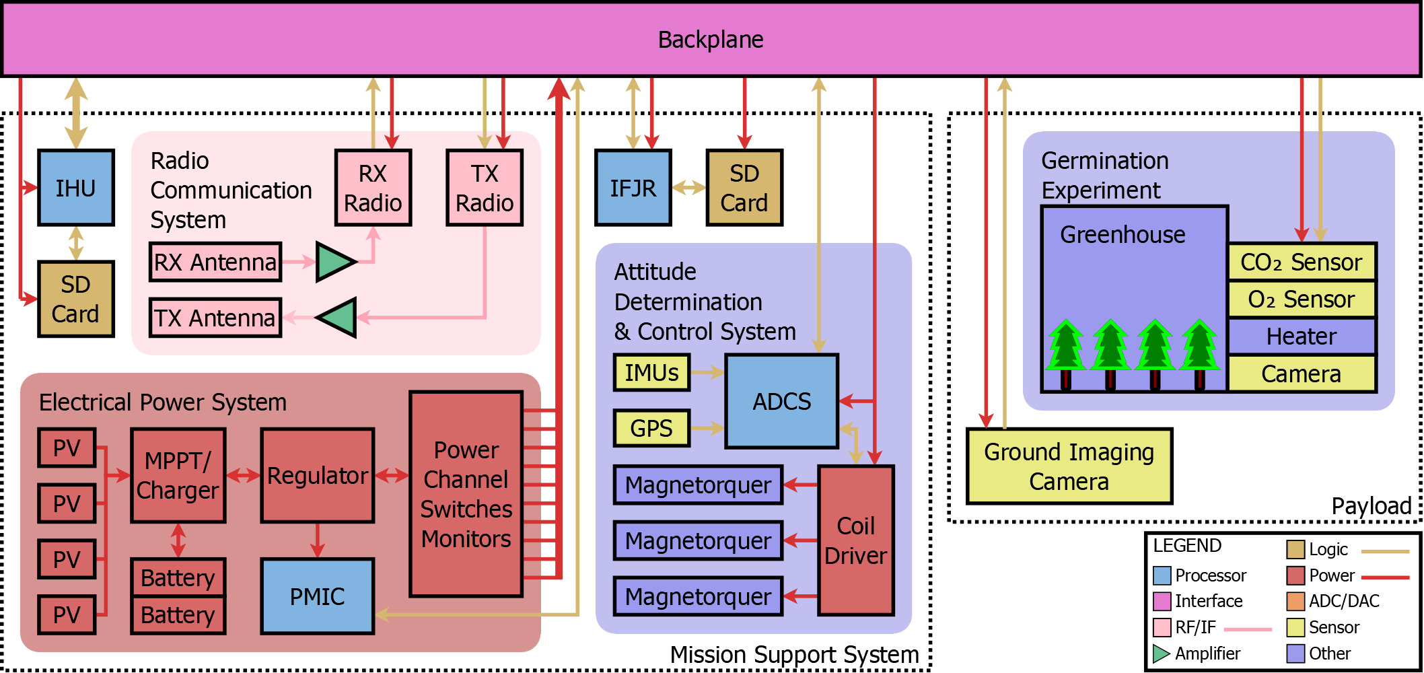

Figure 2: CougSat-1 Functional Block Diagram

Germination Experiment

EPS

Avionics (IHU, IFJR, & ADCS)

RCS

Earth Cameras

Laser Beacon

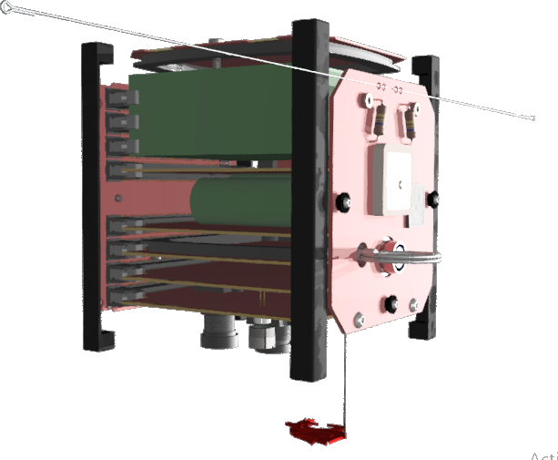

Solar Panel

Magnetorquer

RCS Antenna

GPS Antenna

Radiation Sensor

RBF Pin

Deployable Cougar Head

Figure 3: Preliminary 3D Rendering

## 5.1 Mission Support System

The mission support system consists of the mandatory subsystems for basic satellite operations. Future CougSats will share a similar, if not identical, mission support system. Below is a synopsis of their function, see each subsystem’s documentation for more details.

### 5.1.1 IHU – Internal Housekeeping Unit

The IHU is the main processor on CougSat-1. It, as its name suggests, performs the housekeeping tasks. These tasks include periodically checking the satellite’s health and creating data packets. It also manages communication on the backplane; a subsystem talks though the IHU to another subsystem or the ground.

### 5.1.2 EPS – Electrical Power System

The EPS gathers, stores, regulates, distributes, and manages all electrical power in CougSat-1. Energy from the sun is gathered through solar cells and stored in batteries. The EPS regulates two rails to 3.3 V and 5.0 V. Theses rails are distributed over the backplane on independent channels. The PMIC, power management integrated circuit, monitors and operates the EPS and is the only processor on CougSat-1 that cannot be turned off, except if the deployment switch is depressed. It functions as the minimal operations processor; during safe mode, it and the RCS’s receiver are the only devices operating.

### 5.1.3 ADCS – Attitude Determination and Control System

The ADCS handles positioning CougSat-1 in a desirable orientation. The primary source of attitude knowledge comes from an array of magnetometers, accelerometers, and gyroscopes. The ADCS controls attitude with the use of three air-cored magnetorquers. They generate a magnetic field that, through interaction with Earth’s magnetic field, induce a torque on CougSat-1.

The ADCS also performs a maneuver called “Roast the Chicken” whenever temperatures are out of nominal. During which CougSat-1 begins to revolve in order to evenly distribute the time a side is exposed to the sun, and thus its temperature. The ADCS might also selectively heat or cool one section that is nearing dangerous levels.

### 5.1.4 RCS – Radio Communication System

The RCS uses radio frequency signals to send and receive data to and from the ground. The frequencies are in the amateur radio (HAM) bands 2 m and 700 mm. The use of HAM radio allows CougSat-1 to communicate with operators around the world for distributed reception which increases the contact duration; a single station can see the satellite five to seven times a day for five to fifteen minutes each.

### 5.1.5 IFJR – In-Flight JTAG Reprogrammer

The IFJR connects via JTAG to each processor to program them whilst in orbit. This allows CiS to update software on CougSat-1 after it has been deployed and orbiting in LEO.

### 5.1.6 Mechanical Structure

The mechanical structure supports all of the components and boards in CougSat-1. The structure conforms to the CubeSat specifications, see their [document](http://www.cubesat.org/resources/) for details. During launch, it protects everything from the high acceleration and vibration. In orbit, it holds the subsystems rigidly together such that the ADCS can effectively orient CougSat-1 along with its subsystems.

## 5.2 Payload

The payload achieves the mission objectives. Each objective often has its own section in the payload. Below is a synopsis of each subsystem that fulfils a mission objective.

### 5.2.1 Validating the Mission Support System

As the primary mission of CougSat-1 is to develop a mission support system, the health statistics will be the most beneficial payload. On CougSat-1 there will be dozens of environmental sensors. Roughly 40 temperature sensors will monitor each processor and integrated circuit, in addition to the solar panels, and structure. Two radiation sensors, with different filters, measure the amount of beta and gamma radiation impacting CougSat-1. The EPS measures the amount of power the sun is irradiating onto the solar panels.

### 5.2.2 Germination Experiment

The Astrobiology department of WSU is designing an experiment to test plant germination in microgravity. CougSat-1 will be testing an initial design of the experiment. The experiment consists of a pressurized greenhouse with seeds and growth nutrient. A camera, an O2 sensor, and a CO2 sensor monitor the seed’s life status. A heater will keep the seeds at a proper temperature. The seeds will receive sunlight through a transparent window.

### 5.2.3 Earth Imaging

A high-resolution camera with a wide-angle lens will photograph earth. A deployable cougar head will be in the frame to prove there is a cougar in low Earth orbit. A second camera with a telephoto lens will take photos of small objects of interest such as Pullman. The cougar head will not obscure the telephoto camera.

# 6 Spacecraft Operation

CougSat-1 operates in various modes based on various factors, namely power level and current objective. These modes dictate what CougSat-1 can, cannot, and must do.

## 6.1 Before Deployment

Per the CubeSat specifications section 3.3: Electrical, CougSat-1 must be powered off until ejection from the P-POD. Deployment switches on the end of the structural rails are used to detect when the satellite is inside the P-POD. After the satellite is integrated into the P-POD, the EPS turns off, and thus every subsystem. To test the system and prepare for launch, a remove before flight (RBF) pin is inserted which overrides the deployment switches. Then, through the umbilical, CougSat-1’s subsystems are double checked, and it is told it is going to go into orbit.

## 6.2 Immediately Following Deployment

Once the door to the P-POD opens, its spring ejects the three CubeSats it contains. CougSat-1’s deployment switches are released, and the EPS boots up. It runs a first boot sequence to ensure healthy conditions. Next, the EPS powers up the IHU, which runs a similar initialization routine. The CubeSat specifications prevents deployable mechanisms from releasing until 30 minutes after ejection from the P-POD, and no RF transmission until 45 minutes. The IHU should take a photo of the launch vehicle after ejection, given the launch provider allows it. The ADCS can immediately begin stabilizing the attitude. At the allowed time, likely 50 minutes for margin, the antenna will deploy, the RCS boots up, and normal operations begin.

## 6.3 Normal Operations

Normal operations occur when health data, namely power level, are within nominal values. Below are the various phases of normal operations.

### 6.3.1 Beacon

At a regular interval, the IHU collects data to create a telemetry packet. The RCS transmits this packet along with a voice message. The message informs listeners about CougSat-1, encouraging them to visit our website, and concluding with an enthusiastic “Go Cougs!”. Likely, the packet will be modulated with data under voice, so the voice message and telemetry will be sent simultaneously. This phase is only interrupted during the data transmission phase as they share the same RCS.

### 6.3.2 Charging

During charging, the ADCS orients CougSat-1 to maximize power received. After the batteries are fully charged or charged to a desired amount, this phase is complete.

### 6.3.3 Data Transmission

When CougSat-1 is in range of a known ground station, data transmission phase is entered. The ADCS orients CougSat-1 to maximize the antenna gain to the ground. The IHU and RCS begin constant bidirectional communication to send and receive data. After LOS timeout, this phase is complete.

### 6.3.4 Science

The science phase is mainly related to the ADCS having to orient the craft to take a sensor reading. This is usually to take a picture of a region of interest. Simple data collection science, such as the germination experiment, can happen without CougSat-1 being in the science phase.

### 6.3.5 Eclipsed

Whenever the earth eclipses the sun, the eclipse phase occurs. As the only source of energy is in the batteries, the charge level dictates the available functionality. Normally the batteries will be plenty charged and CougSat-1 can operate at full functionality.

## 6.4 Safe Mode

Safe mode is when all non-essential subsystems are shutdown to preserve the health of CougSat-1. The only subsystems that are on during this mode are the EPS and the receiver of the RCS. Safe mode is usually triggered when the power level is at a critical state.

1. K&K Associates (2008). [Earth’s Thermal Environment](http://www.tak2000.com/data/planets/earth.htm). *Thermal Environments JPL D-8160*.
2. Illinois Tiny Satellite Initiative. [Thermal Control](http://cubesat.ece.illinois.edu/Structure.html). *CubeSat @ UofI*.
3. NOAA (2015). [The World Magnetic Model](https://www.ngdc.noaa.gov/geomag/WMM/). *NOAA Geomagnetic Data & Information.*